TECHNICAL SPECIFICATION

Power Generation Project

Project name:
Date: Dec, 2008
Product type : Stationary power plant
Engine configuration: 8×SXD-MAN 9L32/40

Contents
Ⅰ General 3
Main data of the power plant 3
Derating of DG output 3
Water requirement 3
Quality of Light Fuel Oil (LFO) 3
Lube oil characteristics 3
Codes and standards 3
Ⅱ. General layout 3
Main DG building 3
DG room 3
Auxiliary room 3
Switching room 3
Cooling water station 3
Tank area 3
Ⅲ. Diesel generating set 3
Specification of DG set 3
Main data of diesel engine 3
Main data of generator 3
Performance of DG set 3
Ⅳ Mechanical auxiliary system 3
Fuel oil system 3
Lube oil system 3
Cooling water system 3
Compressed air system 3
Air intake/Gas exhaust system 3
Ⅴ. Electrical control system 3
Electrical equipment 3
Primary cabling 3
Secondary circuit 3
DC system 3
Performance data detection 3
Main alarms of DG sets 3
Engine control 3
Auxiliaries control 3
Factory power supply 3
Ⅵ. Project and scope of supply 3
Boundary 3
Scope of supply 3

Ⅰ General
The proposed stationary 8 x 4.1MW diesel power generating plant is for base load application and intended for electricity production operation in parallel with public supply system.
The diesel engine is connected with the generator via flexible coupling. The fuel for DG sets can be either diesel oil or heavy oil.
The mechanical auxiliary equipment of the DG will be grouped into functional modules to facilitate installation and operation.
Single bus design is used for its electrical design i.e. the power generated from 8 DG sets will be output to the bus. Power supply for the equipment in power plant itself will be taken from the bus through 11kV/0.4kV transformer. No additional standby generating sets are needed.

Main data of the power plant
The power plant mainly consists of 8 sets CLF4100/11000 diesel generating sets manufactured by Shaanxi Diesel Heavy Industry Co., Ltd.(SXD).
Rated power of each DG set under rated speed and ambient conditions:
- Electrical power (60Hz) 4000kW
- Apparent power 5000kVA
-Power factor 0.8
The DG set can output power efficiently under the following ambient conditions:
- Ambient temperature 5～45℃
- Elevation ≤1000M
- Relative humidity ＜95%
- Water temperature at air cooler inlet 45℃
The DG sets can output rated power continuously and are capable of temporary 110% overload for 1 hour in every 12 operating hours under the following conditions:
Ambient temperature 25℃
Atmospheric pressure 100kPa
Cooling water temp. at air cooler inlet 25℃

Derating of DG output
The output and fuel oil consumption rate are to be corrected according to relevant technical documents of the diesel engine manufacturer when the service condition on site does not conform to the standard conditions specified in ISO3046-1995.

Water requirement
HT water and injector cooling water

Normal condition | Clear
PH | 6.8--8
Total hardness (CaCO₃ in ppm) | mg/l | max | 100
Chlorinity | mg/kg | max | 60
Total salinity | mg/kg | max | 250
Density of acid ion ( SO²⁻₄) | mg/kg | max | 60
Fe | mg/kg | max | 0.3
Silicon dioxide | mg/kg | max | 50
Residue on evaporation | mg/kg | max | 400

Quality of Light Fuel Oil (LFO)
Viscosity, min. | cSt at 40℃ | 2.8
Viscosity, max. | cSt at 40℃ | 14.0
Density, max. (at 15 °C) | g/ml | 0.92
Conradson carbon res. max. | % mass | 3.0
Sulphur, max. | % mass | 2
Vanadium, max. | ppm | 100
Sodium, max. |  | 0
Ash, max. | % mass | 0.05
Water, max. | % Vol | 0.30
Water before engine, max. | % Vol | 0.2
Flash point, closed Pensky-Martens, min. | ℃ | 60
Pour point, upper max. | ℃ | 6
Aluminium + silicon, max. | mg/kg | 25
Total sediment potential, max. | % mass | 0.1

Lube oil characteristics
Lube oil for engine lubrication and rockerarm lubrication:
Viscosity: SAE40
Total base number (TBN): ＞20
Please consult recommended lube oil specifications of the engine manufacturer for specific lube oil to be used.
Lube oil for governor and turbocharger:
HU45(GB2537-81)

Codes and standards
The plant will be designed and manufactured according the following codes and standards.
Mechanical system: Relevant ISO and GB standards
Electrical system: IEC standards.

Ⅱ. General layout
This 8 x 4.1MW diesel power generating plant will occupy an area dividing into four sections i.e. main DG building, cooling water station, tank area and heavy fuel treatment station.

Main DG building
The main DG building consists of three rooms i.e. switching room, DG room and auxiliary room.

DG room
The elevation of the DG room is approx. 16m equipped with a 7 ton bridge crane for maintenance and lifting of components. 8 DG sets are laid out in parallel transversally.

Auxiliary room
The auxiliary room is on the engine side of the DG room . Auxiliary equipment such as oil pumps, water pumps, heat exchangers, air compressors, air bottles and some pipes will be installed in the room and the air intake and gas exhaust pipes as well as HT water expansion tank will be installed at the top of the room.

Switching room
Switching room is located at the generator side of the DG room. There are specific rooms for high voltage, central control, switching gear and transformer.

Cooling water station
A fresh water pond will be build in the Plant. Low temperature water circulating pump, central plate heat exchanger and LT water circulating pump. Plant water treatment facilities are located in the water treatment room. There is a water pump room for distinguish pump and pumps for daily life and production.

Tank area
Fuel oil storage tanks in the tank area will be built together comprising two or three 1,000m³ fuel oil storage tanks and eight 40m³ light diesel oil service tank. The capacity of the fuel oil tanks can enable the operating of 8 DG sets for15 days.
Position for slag oil is reserved in the tank area. Transfer pumps for light diesel oil and heavy fuel oil will be installed inside the tank area.

Ⅲ. Diesel generating set
CLF4100/11000 DG set consists of one set of MAN 9L32/40 diesel engine as prime mover, one generator, excitation system and AVR, control and monitoring system, protection system and various auxiliary equipment. The diesel engine and the generator will be installed on separate foundation block and connected through flexible coupling. The DG set features reliable running, prolonged TBO and easy maintenance.
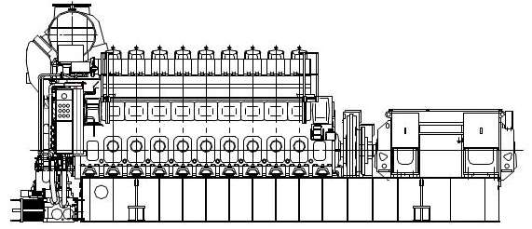

Specification of DG set
Type CLF4100/11000
Rated power 4100 kW
Rated voltage 11kV
Rated current 268.8 A
Number of pole pairs 5
Power factor 0.8 (lagging)
Rated frequency 60 Hz
Rated speed 720 r/min
Phase 3 phase
Excitation brushless excitation
Dry Weight 84 ton
※External dimension(L×W×H) 11,640 x 2,710 x 5,120 mm
※ The dimensions and weight may vary depending on the generator make and type.

Main data of diesel engine
9L32/40 engine is a four stroke, single action, direct injection, gas turbocharging, intercooler medium speed high power diesel engine.
Type | 9L32/40
Model | 4 stroke, V-type, direct injection, gas turbocharging, air intercooled
N0. of cylinders | 9
Rotating direction | clockwise (view from PTO)
Cylinder bore | 320 mm
Stroke | 400 mm
Swept volume | 32.17 dm³
Compression ratio | 14.5/1
Type of combustion chamber | direct injection
Injection method | mechanical drive, single body injection pump
Starting method | compressed air starting
Max. continuous rating (MCR) | 4500kW
Continuous service rating (CSR) | 4050kW
Overload power (1h out of 12 h) | 4950kW
Rated speed | 720 r/min
Mean effective pressure | 2.49MPa
Max. explosion pressure | 19.0±0.29MPa
Min. stable speed | 250 r/min
Firing speed | 80 r/min
Exhaust temp. at cyl. outlet | 510±50℃ (difference between any two cylinders ≤50℃)
Fuel oil consumption | 185+5％ g/kw.h （Lev= 42700kj/kg）
Lube oil consumption | ≤1.0 g/kw.h
External dimension | 7800 x 2695 x 4385 mm（L×W×H）
Weight (dry) | 51 ton

Main data of generator
Type TFW4000-8
Rated power 4000kW
Rated voltage 11kV
Rated speed 720 r/min
Rated frequency 60Hz
Power factor 0.8 (lagging)
Efficiency 96%
Insulation Class F
Protection IP23
Cooling method Air cooling
Excitation Brushless excitation
Lubricating method Complex lubricating
Bearing lube oil N46 (GB443-89)
Weight
External dimension

Performance of DG set
Steady state voltage deviation ±2.5%
Transient voltage regulation within +20%～ -15%
Voltage recovery time ≤1.5 second
Voltage fluctuation ≤1%
No-load voltage setting range 95% --105% rated voltage
The distortion rate of sinusoidal waveform
of line voltage at no-load rated voltage. ≤5%
Steady state frequency deviation 5%
Transient frequency deviation ±10%
Frequency recovery time 7 second
Frequency fluctuation ≤1%

Ⅳ Mechanical auxiliary system
The proper function of the DG-set is dependent on the mechanical auxiliary systems. The proposed systems have been optimized for the this particular plant. The function of the systems are to provide the engine with fuel, lubricating oil, starting air, cooling water and charge air at required quantity and quality as well as to dispose of exhaust gases in a proper manner.

Fuel oil system
The main function of the fuel oil system is to supply the Diesel engine with fuel oil of the necessary amount, pressure, temperature, viscosity and quality during all loads and environmental conditions.. The power plant is using Light Fuel Oil as the main fuel.

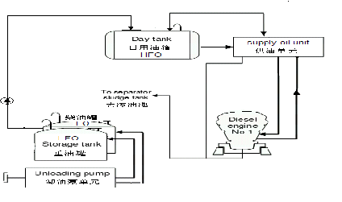
1. Fuel oil storage system
Diesel oil transfer pumps are to be equipped to facilitate unloading of fuel oils. The diesel oil transfer pump is for delivering diesel oil to the diesel oil daily tank for starting ,running and stop operations of the DG sets.
Main facilities in the fuel oil storage system are
Strainer 8 sets
LFO transfer pump 4 sets
LFO delivery pump 2 sets
LFO daily tank 8 set
LFO storage tank 2 sets
Light fuel oil daily tanks are all equipped with level indicator and level switches for alarm and control.

2. LFO feeding unit 4 sets
The function of the feeding pump unit is to pump fuel oil from the storage tank to the day tank. It provides the engine with filtered fuel of correct quantity and pressure. It consists of feeding pump, fine filter, flow meter, booster pump, and control system. Its function is to supply fuel oil to diesel engine at an appropriate viscosity, pressure, flow and cleanness. Transfer pumps and other components are built on a steel frame, which forms one compact unit. Every two DG sets share one unit
Main facilities are as follows:
Electric feeding pump 2 sets
Electric booster pump 2 sets
Duplex strainer 2 sets
Duplex fine filter 1 set
Pressure drop indication and alarm 1 set
Control panel 1 set
Connecting pipe, valve, flanges 1 set
Steel base frame 1 set

Lube oil system
DG lubricating system consists of diesel engine lubricating system and generator lubricating system. The diesel engine lubricating system includes main lube oil circuit, rockerarm lubricating circuit and turbocharger self lubricating system.

1. Main lube oil circuit of diesel engine 1 set/DG set
The main lube oil system of the diesel engine is to supply lube oil for moving parts of the engine. Main lube oil pump delivers lube oil from lube oil tank to engine inlet through lube oil fine filter. Lube oil cooler and three-way thermostatic valve ensure the temperature of the lube oil at engine inlet.
Main facilities are as listed below:
Electric lube oil delivery pump 2 sets
Lube oil cooler 1 set
Lube oil fine filter 1 set
Thermostatic valve 1 set
Control panel 1 set
Connecting pipes, valves, flanges 1 set
Steel base frame 1 set

2. Lube oil separating unit 4 sets
The function of lube oil separating unit is to separate the water content and particles in the main lubricating system at fixed intervals. Two DG sets share one unit. Lube oil of two DG sets can be separated during operation of DG sets.
Each lube oil separating unit consists of the following facilities:
Lube oil separator 2 sets
Filter 2 sets
Heater 2 sets
Slag oil tank 1 set
Control panel 1 set
Connecting pipe, valve, flange 1 set
Steel base frame 1 set

3. Lube oil storage system 1 set/Plant
For storage, compensation and refill of lube oil for the Plant.
Lube oil storage tank 1 set
Lube oil delivery pump 1 set
Engine circulating lube oil tank 1 set
Waste oil tank 1 set

4. Emergency lube oil system
For supplying necessary lube oil for stop of engine when accidents such as loss of power, faulty lube oil pump etc.
Main facilities:
Gravity oil tank 8 sets
Automatic oil feeding device 8 sets
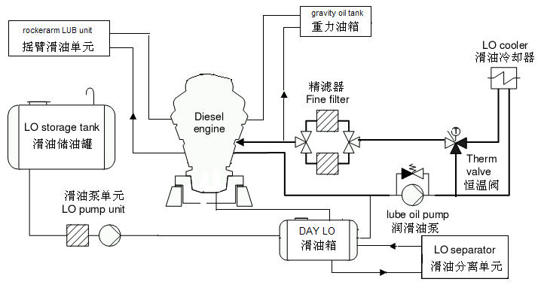

Cooling water system
Engine cooling water system comprises three portions i.e. high temperature water circuit, low temperature water circuit and injector cooling circuit. LT water is cooled by cooling tower. HT water and injector cooling water are cooled by LT water through heat exchangers.

1. LT water circulating system 1 set/Plant
LT water circulating system consists of pump station and cooling tower. Its function is to cool air cooler, lube oil cooler, HT water cooler and injector cooler.
Main facilities are as follows:
LT circulating pump 8 sets
Cooling tower 8 sets

2. HT water system 1 set/DG
HT water system is to cool cylinder liners, cylinder heads and turbocharger consisting of cooling unit and expansion tank.
Main facilities included in the cooling unit are:
HT water pump 2 sets
HT water cooler 1 set
Thermostatic valve 1 set
Control panel 1 set
Connecting pipe, valve, flange 1 set
Steel base frame 1 set

3. Injector cooling water system 1 set/DG
Main facilities are:
Injector cooling water pump 2 set
Injector cooler 1 set
Thermostatic valve 1 set
Cooling water tank 1 set
Control panel 1 set
Connecting pipe, valve, flange 1 set
Steel base frame 1 set
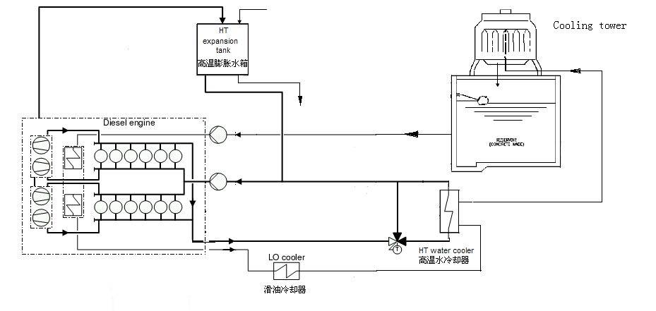

Compressed air system 1 set/Plant
The compressed air system is to supply compressed air for engine starting. Air cooled air compressor produces compressed air and the air will be stored in the starting air bottle and low pressure control air bottle. The capacity of the starting air bottle shall enable 12 times starting of the 2 DG sets.
Main facilities included are:
Air compressing unit 2 set automatic start/stop
Starting air bottle 4 sets
Control air bottle 4 set
Relief valve 4 set
Control air treatment device 4 set
Local air control panel 1 sets

Air intake/Gas exhaust system 1 set/DG
Air intake/gas exhaust system consists of air filter, air intake pipe, turbocharger, air cooler, air manifold, exhaust gas manifold, gas boiler and silencer.
The air outside the building enters into the turbocharger through air duct after filtration of the air filter. The high temperature air after supercharging is cooled by the air cooler and enters into cylinders for combustion through air pipes. The high temperature gas with high pressure after combustion enters into turbocharger through exhaust gas pipes and pushes the turbocharger to rotate and in the meantime drives air compressor for supercharging. The exhaust gas is divided into two routes, one is emitted into open air through silencer, the other goes to the gas boiler to produce steam. The flow of exhaust gas in each route can be regulated through valve.
Exhaust silencer 1 set
Air filter 1sets
Exhaust pipe expansion joint 1sets
Exhaust manifold expansion joint 1 sets
Air intake pipe expansion joint 1sets

Ⅴ. Electrical control system
The outgoing of 2 DG sets connected to the 11KV bus, which is single bus. The frequency of the local power grid is50/ 60Hz. The short circuit current of single DG set is 2.69kA. The max short circuit current of 11kV bus is 16.4kA. The 11kV circuit-breaker is indoor vacuum circuit-breaker, whose rated current is 20kA. The 11kV switchgear is indoor fixed switch cubicle.
The factory power is taken from 11kV bus via factory transformer to lower the voltage down to 0.4KV and connected to switchgear which supplies power to auxiliaries control system and for workshop lighting , ventilation, security and common equipment.
The 2 DG sets have an integrated control system, which performs the control, protection, monitoring functions of the DG sets.

Electrical equipment
No. | Designation | Quantity
1 | Local control panel | 8
2 | Generator control cubicle | 8
3 | PT cubicle | 8
4 | CT cubicle | 8
5 | Generator outgoing switch cubicle | 8
6 | Neutral earthing cubicle | 8
7 | Generator protection cubicle | 8
8 | DC24V panel | 2
9 | DC110V panel | 2
10 | Common pump control panel | 1
12 | 0.4KV control cubicle | 1
13 | 0.4KV switch cubicle | 1
14 | Factory power control cubicles | 1
15 | 0.4KV compensation panel | 1
16 | Transformer 11KV/0.4KV 1250KVA | 1
17 | 0.4KV outgoing cubicles | 1
18 | Transformer incoming switchgear cubicle | 1
19 | Busbar PT cubicle | 1
20 | 11KV outgoing cubicle | 1

Primary cabling
The primary cabling of the Plant is 11KV single bus. The output of 2 DG sets are all connected to 11KV bus. The final outgoing circuit and outgoing way shall be decided after confirmation with the customer. In this proposal the power output circuit is designed as two circuits output and the outgoing way as geosyncline cables.
In the 11kV bus of primary cabling diagram, the factory power supply is taken from the 11kV bus via 11kV/0.4kV factory transformer. The 11KV electrical cubicles for primary cabling are XN₂ fixed switch cubicle. The main equipment includes generator output cubicles, PT cubicles, neutral earthing cubicles, CT cubicles, outgoing switch cubicle and factory power transformer switch cubicle.
1 . Generator output cubicles
Automatic and manual breaker close and trip switch
Differential protection current signal
Generator neutral earthing fault protection
Circuit-breaker and motor heater interlock with fan motor.
Stop the generator heater when close the generator outgoing circuit-breaker and start the generator ventilation motor simultaneously. Stop the motor when the circuit-breaker trip.
Enable the manual and electrical operation of close and trip.
2. Neutral earthing cubicles
Supply the differential protection circuit current signal
Supply voltage signal for exciting automatic regulator
Supply current signal for zero sequence protection circuit
3. PT cubicle
Supply voltage signal for active power, reactive power, three-phase current, power factor and frequency measure.
Supply generator protection voltage signal
4. CT cubicle
Supply current signal for excition regulation and active and reactive power meter
Supply generator protection voltage signal
5. Outgoing cubicle
Supply outgoing circuit for power users.
6. Factory transformer switch cubicle
Supply power to factory transformer
7. PT cubicle
Supply bus voltage
Equipped with bus PT

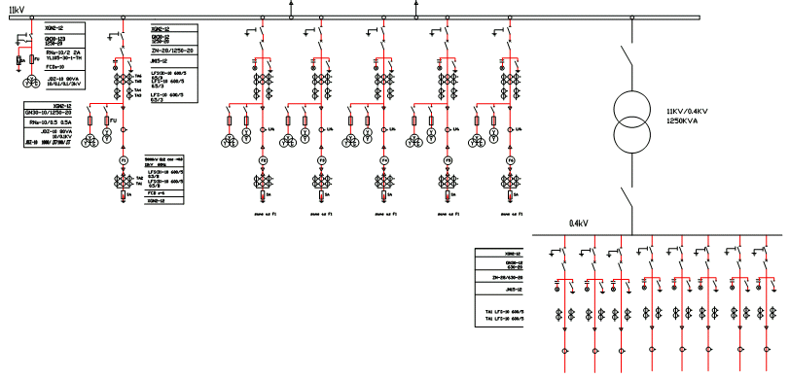
Secondary circuit
The secondary system of the Plant includes mainly he control, protection and monitoring system which uses normal magnetic relays. Generator protection and the protection of transformer and wirings are realized through integrated protection devices. The secondary protection devices are integrated into one control panel, which are installed in the control room.
DG sets and 11KV busbar use the manual synchronizer to realize the grid paralleling. The voltage and frequency regulation for grid paralleling is realized through central control table.
DG sets protection in secondary system contains the following :
- Differential protection
- Reverse power protection
- Overload protection
- Over voltage protection
- Combined under voltage and over current protection
- Neutral earthing protection
- Quick trip and over current protection for 11KV busbar outgoing switch
The electrical data of all DG sets are gathered at the central control table and displayed, recorded and printed by computer.

DC system
The DC power system of the Plant has two types of load current i.e. DC24V 20AH and DC110V 80AH.
The diesel engine and related instruments use DC24V. DC110V is used for main control room and other Plant control systems, protection and communication, and emergency lighting system.

Performance data detection
The performance data of all DG sets are communicated to the central control table and displayed, recorded and printed by computer.
- Air temp. at turbocharger inlet
- LT water temp. at air cooler inlet
- HT water temp. at engine outlet
- Lube oil temp. at engine inlet
- Lube oil pressure at engine inlet
- Pressure in LT water pipe
- HT water pressure at engine inlet
- Max explosion pressure
- Gas temp. at cylinder outlet
- Average exhaust gas temp., on one bank
- Exhaust gas temp. at turbine inlet
- Exhaust gas temp. at turbine outlet
- Vacuum at turbocharger inlet
- Exhaust backpressure at turbocharger outlet
- Turbocharger speed

Main alarms of DG sets
Temperature
- HT water temp. at engine outlet
- Lube oil temp. at engine inlet
- Lube oil temp. at turbocharger outlet
- Exhaust gas temp. at cylinder outlet
- Average exhaust gas temp. on each bank
Pressure
- Lube oil pressure at engine inlet
- Lube oil pressure at turbo charger inlet
- Fuel oil pressure at engine inlet
- Pressure in overspeed protection air receiver
Safety stop
- Overspeed protection
- Low lube oil pressure at engine inlet
- High HT water temp. at engine outlet

Engine control
There are two control mode for engine i.e. local control and central control, which can be selected by the local switch. The local control can facilitate maintenance and inspection works. Besides the instruments for easy monitoring, the local control panel also contains control elements for starting, stop, emergency stop and speed regulation, which enable the start, stop, overspeed protection, emergency stop and local/central switchover operations. Each DG set is equipped with one LCP. Part of performance data such as engine speed, start air pressure, engine lube oil pressure at engine inlet are monitored by the special instruments.

Auxiliaries control
Control of auxiliaries of engine includes:
Fuel oil pump
Lube oil pump
HT water pump
LT water circulating pump
Injector cooling water pump
Rockerarm lube oil pump
Turning gear motor
start air compressor
Generator ventilation motor (half pipe type )
Generator heater
The start and stop of most auxiliary pumps are controlled by the units in this system. Auxiliary unit shall have its own local control box. Some auxiliaries are controlled in distributing room.3 DG sets share one panel .

Factory power supply
The factory power supply is taken from 11kV bus via the 1250kVA transformer to lower the voltage from 11kV down to 0.4KV and connected to switchgear which supplies power to auxiliaries control system and for workshop lighting , ventilation, security and common equipment.There is automatic power factor compensation device on the 0.4KVbusbar to guarantee the efficiency of DG sets and power supply quality.

Ⅵ. Project and scope of supply
Design and building of all the buildings and facilities within the Plant. Laying of cooling tower cooling pipes for the Plant.

Boundary
The interface between the 11kV bus and the city grid is the outer side of the outgoing bus switch.
The water supply will come from the city water supply system. The interface is at 1 meter outside of the territory of the Plant.
The drain water of the Plant will go to the infiltration basin outside of the Plant.
The interface between the communication system and the city communication network is at 1 meter outside of the territory of the Plant

Scope of supply
NO. | ITEM | SPECIFICATION | QTY. | SCOPE
 |  |  |  | SXD | CT
A | DIESEL GENERATOR SET |  | 8
A.1 | Diesel engine | SXD-MAN 9L32/40,4500KW,720r/min. | 8 | ●
A.1.1 | Turbocharger |  | 8 | ●
A.1.2 | Air Cooler | Fin and tube type. | 8 | ●
A.1.3 | Governor | Mechanical hydraulic, mounted on engine. | 8 | ●
A.1.4 | Fuel injection pumps | Bosch type, mounted on engine. | 72 | ●
A.1.5 | sensor | ,mounted on engine. | 8 | ●
A.1.6 | Protection devices | Press, temp switches and speed detector, mounted on engine. |  | ●
A.1.7 | Junction Box | For protection devices, mounted on engine. | 8 | ●
A.1.8 | Flywheel | With bolts and nuts. | 8 | ●
A.1.9 | Flywheel turning device | Motor drive type, mounted on engine. | 8 | ●
A.1.10 | Leak oil tank | mounted on engine. | 8 | ●
A.1.11 | Engine bed |  | 8 | ●
A.2 | Alternator with AVR | 4100KW,10500V,60HZ. | 8 | ●
A.3 | Coupling
B | TOOLS FOR ENGINE | Special tool for maintenance. | 1 | ●
C | SPARE PARTS |  | 1 | ●
D | TECHNICAL INFORMATION |  | 1 | ●
E | FUEL OIL SYSTEM
E.1 | D.O. transfer pump |  | 4 | ●
E.2 | Strainer for D.O. transfer pump |  | 2 | ●
E.3.1 | D.O. storage tank | 1000Ton. | 2 |  | ●
E.3.2 | D.O. service tank | 50Ton. | 8 |  | ●
E.4 | Float swith for D.O. service tank |  | 4 | ●
E.5 | Pressure relief valves for fuel system |  | 8 | ●
E.6 | F.O. feed pump unit |  | 2 | ●
E.6.1 | F.O. feed pump |  | 4
E.6.2 | Strainer for H.O. feed pump | 200mesh duplex type. | 4
E.6.3 | F.O. secondary filter | 10μ,mounted on engine. | 8
E.6.4 | H.O. flow meter |  | 2
E.6.5 | Relief valves |  | 2
E.6.6 | Press meter |  | 2
E.6.7 | Underpan and stand |  | 2
E.7 | Leak fuel Tank | 2000L. | 1 |  | ●
E.8 | leak fuel evacuation pump |  | 2 | ●
F | LUB. OIL SYSTEM :
F.1 | Lub. oil Sump tank |  | 8 |  | ●
F.2 | Lub. oil filter for bearing | 300 mesh duplex type. | 8 | ●
F.3 | Lub. oil heat exchanger |  | 8 | ●
F.4 | Lub. oil thermostat valve | 50-65℃ | 8 | ●
F.5 | Lub. oil feed pump |  | 16 | ●
F.6 | Gravitational oil tank |  | 8 |  | ●
F.7 | Lub. oil centrifuge separator unit | 1800~2000L/h for SAE#40 Lub.Oil. | 8 | ●
F.8 | Sludge Lub. oil evacuation pump | 3.3m3/h, 3.2kg/cm2,11KW | 8 | ●
G | COOLING WATER SYSTEM :
G.1 | Cooling tower |  | 8 | ●
G.2 | Cooler water pump |  | 16 | ●
G.3 | Strainer for cooler water pump |  | 16 | ●
G.4 | Jacket water pump |  | 16 | ●
G.5 | Jacket water heat exchanger |  | 8 | ●
G.6 | Jacket water thermostat valve | 75-90℃ | 8 | ●
G.7 | Jacket water expansion tank with stand |  | 8 |  | ●
G.8 | Level switch for above for Jacket water expansion tank | For Low level alarm | 8 | ●
G.9 | Nozzle cooling water pump |  | 16 | ●
G.10 | Nozzle cooler |  | 8 | ●
G.11 | Nozzle cooling water thermostat valve | 60-75℃ | 8 | ●
G.12 | Nozzle cooling water tank | 200L | 8 |  | ●
H | STARTING AIR SYSTEM :
H.1 | Starting air compressor | 36m3/h,30kg/cm2,7.5KW,motor driven. | 2 | ●
H.2 | Starting air bottle | 2000L×30kg/cm2,with 32kg/cm2 relief valve | 4 | ●
H.3 | Reducing air valve | 30kg/cm to 7kg/cm2 | 8 | ●
I | EXHAUST GAS SYSTEM
I.1 | Exhaust gas expansion joint |  | 16 | ●
I.2 | Exhaust gas expansion joint |  | 16 | ●
I.3 | Exhaust gas silencer |  | 8 | ●
J | INTAKE AIR SYSTEM
J.1 | Heavy duty industrial use type air filter | Dry and washable type filter to be mounted on turbocharger. | 8 | ●
J.2 | Input air expansion joint |  | 8 | ●
K | SOFT WATER FEED SYSTEM
K.1 | Water Softerner | 5T/h,钠离子交换流动床. | 1 |  | ●
K.2 | Soft water storage tank | 5Ton | 1 |  | ●
K.3 | Pressurizing pump for soft water system |  | 2 |  | ●
L | ELECTRIC EPUIPMENT INSIDE POWER STATION
L-1 | DIESEL ENGINE CONTROL PANEL |  | 2 | ●
L-2 | AUXILIARY EQUIPMENT CONTROL PANEL |  | 3 | ●
L-3 | AUXILIARY EQUIPMENT POWER PANEL |  | 4 | ●
L-4 | 440V STETION SERVICE CB PANEL |  | 1 | ●
L-5 | AUXILIARY TRANSFORMER: 10.5/0.4KV,500KVA |  | 1 | ●
L-6 | AUXILIARY DIESEL GENERATOR CB PANEL |  | 1 | ●
L-7 | AUXILIARY DIESEL GENERATOR CONTROL PANEL |  | 1 | ●
L-8 | GENERATOR INCOME CB PANEL |  | 2 | ●
L-9 | GENERATOR INCOME CB CONTROL PANEL |  | 2 | ●
L-10 | NEUTRAL GROUNDING PANEL: |  | 1 | ● | ●
L-11 | 10KV PT PANEL |  | 1 | ●
L-12 | STSP UP TRANSFORMERS INCOME CB PANEL |  | 1 | ●
L-13 | STSP UP TRANSFORMERS INCOME CB CONTROL PANEL |  | 1 | ●
L-14 | AUXILIRY TRANSFORMER INCOME CB PANEL |  | 1 | ●
L-15 | AUXILIARY TRANSFORMER CONTROL PANEL |  | 1 | ●
L-16 | DC SYSTEM CONTROL PANEL :Battery charger |  | 1 | ●
L-17 | DC BATTERY UNIT:110/24V 100Ah |  | 1 | ●
M | STEP UP TRANSFORMER STATION
M-1 | NCOME CB PANEL: 15000KVA,10.5/10KV |  | 1 |  | ●
M-2 | OUTPUT LINE CB |  | 1 |  | ●
M-3 | OUTPUT LINE CB PANEL |  | 1 |  | ●
M-4 | OUTPUT LINE KNIFE SWITCH |  | 1 |  | ●
M-5 | CT【20KV线路电压互感器】 |  | 1 |  | ●
M-6 | PT【20KV线路电流互感器】 |  | 1 |  | ●
M-7 | NEUTRAL GROUNDING FOR STEP TRANSFORMER |  | 1 |  | ●
M-8 | LIGHTNING ARRESTER EQUIPMENT【避雷器装置】 |  | 1 |  | ●
M-9 | 20KV SYSTEM PROTECTION PANEL【20KV保护柜】 |  | 2 |  | ●
N | POWER & CONTROL CABLE【 电力电缆/控制电缆】: |  |  |  | ●
O | GENERAL EQUIPMENT【通用设备】
O-1 | Maintenance crane【维修吊车】 | 10T | 1 |  | ●
O-2 | Ventilation fans【通风扇】 |  | 6 |  | ●
O-3 | Auxiliary diesel generator | 200KW,440V,60HZ,3相 | 1 |  | ●
O-4 | Cable chimb suction pump |  | 3 |  | ●
SXD: To be supplied by SXD CT: To be Consumer

